

Functional Design Document
Retail Management
eThekwini Municipality
Oracle Revenue Management System (C2M)

This template is used for technical documentation on Oracle consulting projects. See section Use of This Document for style guidance.

April 2024, Version 1.0
Copyright © 2026, Oracle and/or its affiliates
Confidential – Oracle Internal Use Only

Contents
1 Contents ii
2 Introduction 1
2.1 Document Purpose 1
2.2 Scope 1
2.3 Related Work / Dependencies 1
3 Assumptions & Open Items 2
3.1 Assumptions 2
3.2 Open Items 2
4 High Level Approach 3
4.1 Background 3
4.2 To Be Solution 3
4.2.1 Solution Overview 3
4.2.2 Business Process Flow Diagram (whenever applicable) 5
4.2.3 Business Process Description (whenever applicable) 5
4.3 Major Build Components 5
5 Build Component Design 9
5.1 Business Object 9
5.1.1 CM_RetailManagement 9
5.1.2 CM-RetailAccountPriceMgmt 13
CM-RetailAccountPriceMgmt 13
5.1.3 CM-MaintainItemPriceList 15
5.1.4 CM-OrderRetailManagement 18
5.1.5 CM-MaintainOrderInvoice 21
5.1.6 CM-MaintainDeliveryNote 23
5.2 BO Case Lifecycle 25
5.2.1 Maintain Orders 25
5.2.2 Maintain Invoice 29
5.2.3 Maintain Delivery Note 31
5.3 Zone 33
5.3.1 CM-RTLMGMACT 33
5.3.2 CMRTPRRICEMG 33
5.4 Portal 33
5.4.1 CMACTRTM 33
5.4.2 CMORDMGM 34
5.5 Menu 34
5.6 Script 35
5.6.1 CMActRetMain 35
5.6.2 CM-ZoneAlwVI 37
5.6.3 CMActRtlPrcM 37
5.6.4 CM-ZoneBrcVl 37
5.6.5 CMOrdMgmMtAt 38
5.6.6 CM_RMMOVALID 40
5.6.7 CM_RMBBRTORD 40
5.6.8 CM_RMPROFINV 41
5.6.9 CM_RMMROVALD 41
5.6.10 CM_RMMROMAIL 41
5.6.11 CM_RMMRVALID 42
5.6.12 CM_RMOINCALC 42
5.6.13 CM_OrdMgmMt 42
5.6.14 CM_PrintOrdr 43
5.6.15 CM_PrnItmLst 43
5.7 Algorithm Type 44
5.8 Algorithms 47
5.9 UI MAP 49
5.9.1 CM-RetialAccountPriceMgmtDisp 49
5.9.2 CM-RetialOrderMgmtActions 53
5.9.3 CM-RetailManagementDisplay 56
6 Solution Specific Configuration 61
6.1 Message 61
6.1.1 Message 61
6.2 Administrative Activities 61
6.2.1 Characteristics Type 61
6.2.2 Lookup 64
7 Data Requirements 65
8 Security Requirements 66
8.1 Users and Security 66
9 Performance Considerations 67
10 Testing Requirements 68
10.1 Test Scenarios 68
11 Appendix: Document Control 69
12 Appendix: Definitions, Acronyms, and Abbreviations 71

Introduction

Document Purpose
The purpose of the Functional Specification is to outline how the system or product can be configured, extended, modified, localized, and integrated to address specific business requirements.
This document is to address the eThekwini Municipality’s business requirement regarding Community Residential Units .

Scope
In-scope: This includes but not limited to the following significant areas of interest for this component:
- Architecture design considerations for component
- Component behavior designs
- Component data designs necessary for component
- User interface designs required for component
Out-of-scope: The following design areas of interest are not considered in-scope for this project:
- Application setup considerations for component
- Software detailed designs for component
- Changes to logical database design in order to support component design

Related Work / Dependencies
# | Work product / Artifact | Description/Reference link | Document date and version | Artifact dependency (Y/N)
1 | Foundation Design | ethekwini_DSW_026_Foundation_Design | current | Y

Assumptions & Open Items

Assumptions
This Functional Specification assumes the following:
- Only Authorized users will be able to add, modify the Orders, Maintain PriceList, retailers Details

Open Items
# | Issue/action item | Resolution | completion date
001 | Security access | This should be considered when discussion and design of User, access roles will be designed.
002 | Print Functions,Reports and Emails | Depends on BI, Integration Design

High Level Approach

Background
In eThekwini, The Hostels are getting converted in to CRUs. Each management area will have more than one trading area. Existing Data from GIS will be used to create the CRUs. The CRU will further have Blocks, Family Units, and Rooms. These will be maintained as Child Premise to the CRU with different Premise types.
Further the Application for renting the Family Units/Blocks/Beds will be handled in the in C2M using Campaign via Order creation. And once the Application approved Service Agreement will be activated.
Business requirement is to maintain these mentioned Informal trade components in the C2M:
- Create and Maintain CRUs.
- Create and Maintain CRU Blocks.
- Create and Maintain CRU Family Units.
- Create and Maintain Beds.
- Maintaining the Customer Application.

Note to Developer: the following technical detail in document is only for reference purpose and might not contain exact details. This needs to be taken care during development phase.

To Be Solution

Solution Overview
The entities CRUs, Blocks, Home units and rooms will be defined as premises within Oracle C2M. For these, dedicated Business Objects will be created using the Premise Maintenance Object and respective Premise type will be created. All relevant attributes will be stored within the premise’s data area or as premise characteristics These premises will serve as the foundational units for managing CRUs.
Access to CRU Premise Management Portal, Creation of Order using the relevant Campaign will be handled exclusively by authorized users through dedicated application service.
Furthermore, dedicated portals will be developed for Maintaining Block, Home Units, Rooms and beds - These portals will be accessible only to authorized business users, providing them with a secure and user-friendly interface to maintain and manage CRUs Sites efficiently. Portals will help the user to query the existing details and allow them to add /update the details for respective entity.

Campaign and SP Details overview
A new campaign has been introduced to register enrolment requests from customers for beds, rooms, and family units. For each incoming request, an Order will be created under this campaign.
Registration Form Requirements
All required and optional questions necessary for completing the registration form are predefined at the campaign level. These questions must be populated for every Order created.
Package Eligibility Validation
Package eligibility rules have been configured to validate whether a customer qualifies for the requested service based on the form details captured in the Order.
- If all eligibility rules pass, the Order will be created successfully.
- A new Service Agreement (SA) will then be created and linked to the existing Bed Service Point (SP).
Premise Handling
No new premise will be created as part of this process. An existing premise will always be used for creating the Order.
Person and Account Handling
- If a Person and/or Account is provided in the request, the existing records will be used.
- If not provided, the process will automatically create a new Person and Account.
The system will maintain one Service Point (SP) for each bed allocated within a Family Unit or Room.
- If the Service Point already exists for the corresponding premise, it will be reused.
- If the Service Point does not exist, it will be created during Order completion, along with the creation of the associated Service Agreement (SA).
The entities CRUs, Blocks, Home units and rooms will be defined as premises within Oracle C2M. For these, dedicated Business Objects will be created using the Premise Maintenance Object and respective Premise type will be created. All relevant attributes will be stored within the premise’s data area or as premise characteristics These premises will serve as the foundational units for managing CRUs.
Access to CRU Premise Management Portal, Creation of Order using the relevant Campaign will be handled exclusively by authorized users through dedicated application service.
Furthermore, dedicated portals will be developed for Maintaining Block, Home Units, Rooms and beds - These portals will be accessible only to authorized business users, providing them with a secure and user-friendly interface to maintain and manage CRUs Sites efficiently. Portals will help the user to query the existing details and allow them to add /update the details for respective entity.

Business Process Flow Diagram (whenever applicable)
n/a

Business Process Description (whenever applicable)
n/a

Major Build Components
Component type | Component Name | Description
UI Maps | CM-PremCharTypeInfoMaint | To Maintain Characteristic type maintenance.
 | CM-PremCharMaint | Input Map to capture characteristic type
 | CM-PremCharDisp | Display map to display characteristic Type captured data
Zone | CM-CRUBLDT | Zone to retrieve the CRU BLOCK details using Block Address ID
 | CM-CRUBLDT1 | Zone to retrieve the CRU BLOCK details using CRU Premise ID
 | CM-CRUFUDT | CRU Family Unit should be searched by using the Family Unit- name/address
 | CM-CRUFUDT1 | CRU Family Unit should be searched by using the CRU block premise ID
 | CM-CRURMDT | CRU Family Unit should be searched by using the room unit name/address
 | CM-CRURMDT1 | CRU Room should be searched by using House unit premise ID/ CRU block premise ID
 | CM-CRUBDDT | CRU bed SP should be searched using the room unit/Family unit premise
 | CM-CRUBDDT1 | CRU BED should be searched by using the bed number
 | CM-CRUBLUQ | Zone will be utilized to search the CRU block using the query zone/SQL added to it and provide option to edit details using a button/hyper link.
 | CM-CRUFUQ | Zone will utilize to search the CRU home unit using query zone/SQL added to it provide option to edit selected premise details using a button/hyper link.
 | CM-CRURUQ | Zone will utilize to search the CRU room unit using the Query zone/SQL added to it and provide option to edit the selected premise details using a button/hyper link.
 | CM-CRUBDQ | Zone will utilize to search the CRU room unit using the Query zone/SQL added to it and provide option to edit the selected premise details using a button/hyper link.
Portal | CM_CRUBLK | Block portal to add display block details.
 | CM_CRUFU | Family unit portal it displays family unit details.
 | CM_CRURU | Rooms unit portal it displays rooms unit details.
 | CM-CRUBD | Beds unit portal it displays CRU Beds details
Business object | CM-CRUBlockBO | CRU block unit is Block business object
 | CM_CRUFamilyUnitBO | CRU family unit business object
 | CM_CRURoomBO | CRU Room BO
 | CM_CRUBedSPBO | CRU bed SP Business Object
Script | CM-CRUBUMain | This BPA script is used to rendered block BO and attached to the block Navigation option
 | CM-CRUBOProc | This Script should be used to invoke this script to process BO Object
 | CM-CRUFUMain | This script is used to render CRU family unit details for add/edit and it is attached to the block navigation.
 | CM-CRUFUProc | This script should be used to invoke this script to process BO object.
 | CM-CRURUMain | This script is used to render CRU Room Unit details for add/edit and it is attached to the block navigation option.
 | CM-CRURUProc | This script should be used to invoke this script to process BO object
 | CM-CRUBDMain | This script is used to render Bed SP details for add/edit and it is attached to the block navigation option.
 | CM-CRUBDProc | This script should be used to invoke this script to process BO object
 | CM-CRUStVal | This script is attached to the relevant business object and executed during creation or update.
Algorithm Type | CM-SNDWL | This algorithm type is used to send welcome letter
 | CM-SIGNTD | This algorithm type is used to create to do to initiate signing process
 | CM-ISSKEYTD | This algorithm type is used to create to do to issue the keys.
 | CM-UPDPMST | This algorithm type is used to update allocation status on premise
 | CM-CHCKPMST | This algorithm type is used to check premise status.
 | CM-CRTSASP | This algorithm type is used to create SA and SP .
Algorithm | CM-SNDWL | This algorithm type is used to send welcome letter
 | CM-SIGNTD | This algorithm type is used to create to do to initiate signing process
 | CM-ISSKEYTD | This algorithm type is used to create to do to issue the keys.
 | CM-UPDPMST | This algorithm type is used to update allocation status on premise
 | CM-CHCKPMST | This algorithm type is used to check premise status.
 | CM-CRTSASP | This algorithm type is used to create SA and SP .

Build Component Design
This section provides detailed information about all the new and existing Software Components which are getting updated as part of this Functional Specification

Business Object

CM_RetailManagement
This BO will be used to hold the Retailer data. This includes searchable characteristics for the retailer type, retailer name, retailer code, department, retailer status. These characteristics needs to be protected and accessible only by DSW users. This BO also holds the branch code/name, delivery address, "GRN required?" policy for invoice authorization, and status.
Property | Value
Business Object | CM_RetailManagement
Description | Retail Management Menu
Maintenance Object | ACCOUNT
Application Service | F1-DFLTS
Instance Control | Allow new instances
Schema | <schema xmlns:uiHint="http://oracle.com/ouafUIHints">  <accountId fkRef="ACCT" mapField="ACCT_ID" dataType="string"/>  <departmentName label="Department Name" mapField="CHAR_VAL">  <row mapChild="CI_ACCT_CHAR">  <CHAR_TYPE_CD is="CM-DPTNM"/>  <EFFDT is="%effectiveDate"/>  </row>  </departmentName>  <retailerFlag label="Retailer Flag" mapField="CHAR_VAL">  <row mapChild="CI_ACCT_CHAR">  <CHAR_TYPE_CD is="CM_RTLFG"/>  <EFFDT is="%effectiveDate"/>  </row>  </retailerFlag>  <retailerCode label="Retailer Code" mapField="ADHOC_CHAR_VAL">  <row mapChild="CI_ACCT_CHAR">  <CHAR_TYPE_CD is="CM_RTLCD"/>  <EFFDT is="%effectiveDate"/>  </row>  </retailerCode>  <retailerName label="Retailer Name" mapField="ADHOC_CHAR_VAL">  <row mapChild="CI_ACCT_CHAR">  <CHAR_TYPE_CD is="CM-RTMRN"/>  <EFFDT is="%effectiveDate"/>  </row>  </retailerName>  <retailerType label="Retailer Type" mapField="CHAR_VAL">  <row mapChild="CI_ACCT_CHAR">  <CHAR_TYPE_CD is="CM_RTLTY"/>  <EFFDT is="%effectiveDate"/>  </row>  </retailerType>  <retailerStatus label="Retailer Status" mapField="CHAR_VAL">  <row mapChild="CI_ACCT_CHAR">  <CHAR_TYPE_CD is="CM_RTLST"/>  <EFFDT is="%effectiveDate"/>  </row>  </retailerStatus>  <retailerBranch type="group" mapXML="ACCT_DATA_AREA">  <retailerBranchList type="list">  <branchCode label="Branch Code" isPrimeKey="true" dataType="string"/>  <branchName label="Branch Name" isPrimeKey="true" fkRef="ACCT" dataType="string"/>  <deliveryAddress label="Delivery Address" fkRef="PREM" dataType="string"/>  <extReference label="External Refercene ID requiered" dataType="lookup" lookup="F1_SE_TRUEFALSE_FLG"/>  <status label="Status" dataType="lookup" lookup="ACT_INACT_FLG"/>  </retailerBranchList>  </retailerBranch>  <uiHint:startSection label="Logs" sectionColumn="float" visibleOn="displayMap"/>  <cmlogs type="group" mapXML="ACCT_DATA_AREA">  <createdBy label="created By" dataType="string"/>  <createdDateTime label="created Date time" dataType="string"/>  <updatedBy label="Updated User" default="%CurrentUser" dataType="string"/>  <updatedDateTime label="Updated Date Time" default="%ProcessDateTime" dataType="string"/>  </cmlogs>  <uiHint:endSection/>  </schema>
Options | Display Map Service Script
 | Portal Navigation Option

Field Name | Description
Main
Account Id | Primary Key
Department Name | Mandatory. Characteristic Type CM-DPTNM
Retailer Flag | Mandatory. Characteristic Type CM_RTLFG
Retailer Code | Mandatory Characteristic Type CM_RTLCD
Retailer Name | Mandatory Characteristic Type CM-RTMRN
Retailer Type | Characteristic Type CM_RTLTY
Retailer Status | Characteristic Type CM_RTLST
Retailer Branch List
Branch Code | Unique internal identifier for the branch. Mandatory and maps to ACCT_DATA_AREA element branchCode
Branch Name | Full name of the branch (e.g., SPAR – DISTRIBUTION CENTRE). Mandatory and this will be and existing account id the system and maps to ACCT_DATA_AREA element branchName with FK reference to account.
Delivery Address | The physical branch delivery address (C2M Premise Id) maps to ACCT_DATA_AREA element deliveryAddress with FK reference to premise.
External Reference Required? | A Yes/No value to indicate whether the authorization of order requires the external reference or not. Default to ‘No’ if value does not present on migrated account. Maps to ACCT_DATA_AREA element extReferenceFlag with Lookup Value – YES/NO
Status | Current branch status (active/inactive). Maps to ACCT_DATA_AREA element status with Lookup Value – Active/Inactive

Retail Management Input Map
Input MAP should be rendered to maintain Retail and branch Details. These Details will be add /updated by authorized users; hence New Application ser vice needs to create which will be attached to this.
In (C2M) system, each Retailer account, branch account will be represented as a distinct business object, associated with the Account maintenance object.
A new menu should create to attach this Map and used to update Retailer/branch details which will be stored as in C2M Account entity.
Mock Input UI
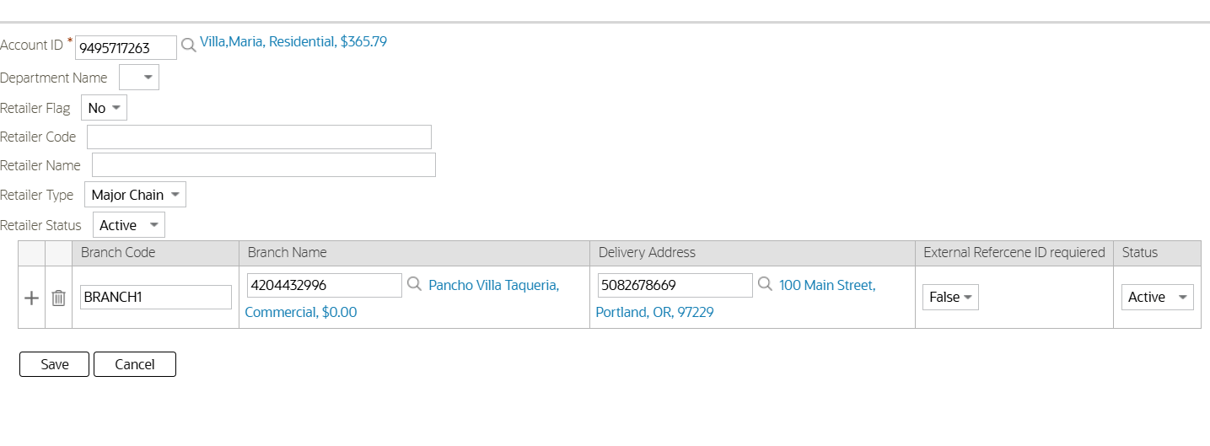
Mock Display UI
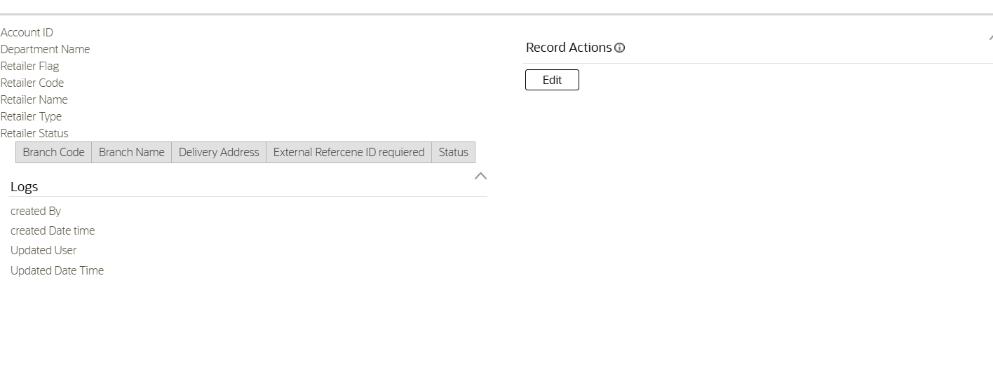
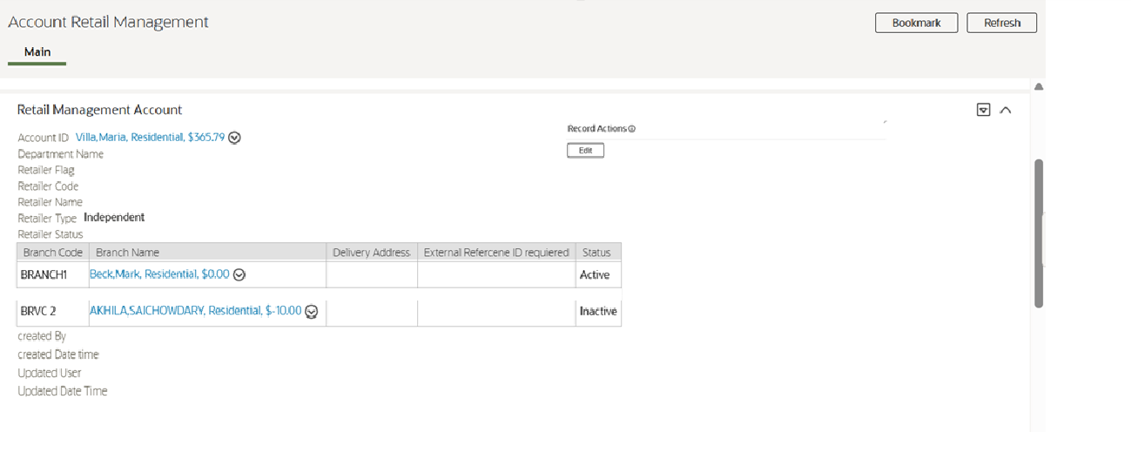
The Edit should open the Input UI with editable data for updating the Retailer data and branch details.

CM-RetailAccountPriceMgmt
Property | Value
Business Object | CM-RetailAccountPriceMgmt
Description | Retailer/Branch-specific price overlay (discount)
Maintenance Object | ACCOUNT
Application Service | F1-DFLTS
Instance Control | Allow new instances
Schema | <schema xmlns:uiHint="http://oracle.com/ouafUIHints">  <accountId mapField="ACCT_ID" dataType="string"/>  <retailerBranchPriceList label="Retailer Price List" type="group" mapXML="ACCT_DATA_AREA">  <bagList label="Retailer Price deatils" type="list">  <productCode label="product code" isPrimeKey="true" dataType="string"/>  <bagType label="Bag Type" dataType="lookup" isPrimeKey="true" lookup="CM_BAG_TYPE_FLG"/>  <effectiveDate mdField="EFFDT" dataType="date" isPrimeKey="true"/>  <endDate label="effective To" dataType="date" isPrimeKey="true"/>  <revisionNumber label="Revison Number" type="group">  <vatData label="VAT Details" type="list">  <revNum label="Revision Number" isPrimeKey="true" dataType="string"/>  <priceExclVAT label="Price Excl. VAT" dataType="string"/>  <vatAmount label="VAT" dataType="string"/>  <priceInclVAT label="Price Incl. VAT" dataType="string"/>  <discountPercent label="Discount %" dataType="string"/>  <costAmount label="Cost" dataType="string"/>  <markUpAmount label="Mark Up" dataType="string"/>  <markUpPercent label="Mark Up %" dataType="string"/>  <stockLevel label="Stock Level" dataType="string"/>  </vatData>  </revisionNumber>  </bagList>  </retailerBranchPriceList>  </schema>

Field Name | Description
Main
Department Name | Mandatory. It is a lookup or characteristic. It is maps to the element Department Name in the ACCT_DATA_AREA.
Revision Number | It identifies the version of the item price list. It maps to the element Revision Number in the ACCT_DATA_AREA.
Effective From | Mandatory. The date which retailer price defines then it becomes effective. It maps to Effective From in the ACCT_DATA_AREA.
Effective To | Mandatory. this date should be later than the Effective Date From. It maps to Effective To in the ACCT_DATA_AREA.
Sale Price Excl. VAT | The price of the product, excluding VAT. It maps to Sale Price Excluding VAT in the ACCT_DATA_AREA.
VAT | The value added tax applicable for the product. It maps to VAT in the ACCT_DATA_AREA.
Sale Price Incl. VAT | The price of the product, including VAT. It maps to Sale Price Including VAT in the ACCT_DATA_AREA.
Discount % | Mandatory. Here percentage can be equal or greater than zero. It maps to Discount Percent in the ACCT_DATA_AREA.
Discounted Sale Amount | The discount price obtained by applying discount percentage is EXCl VAT value. It maps to the element Discounted Sale Amount in the ACCT_DATA_AREA.
Mark Up | Here difference between the discounted price Excl. VAT vale and discounted price values. It maps to element Mark Up in the ACCT_DATA_AREA.
Mark Up % | Here percentage is equal to Mark Up divided by the Cost Price and multiplied by 100. It maps to the element Mark Up Percent in the ACCT_DATA_AREA.
Stock Level | Mandatory. Value must be numerical. It maps to the element Stock Level in the ACCT_DATA_AREA.

Retail Account Price Management Input Map
Input MAP should be rendered to maintain Item Price List of a specific customer/branch on top of the Item price. In this its custom interface hosts negotiated terms, like discount percentage, derived cost/ markup. And this design isolates branch-specific terms, preserving the integrity of the base item price list.
This portal is a Fact-based object and can be launch via the Retail Management Menu and the BO will contain the below elements.

UI Mock Input
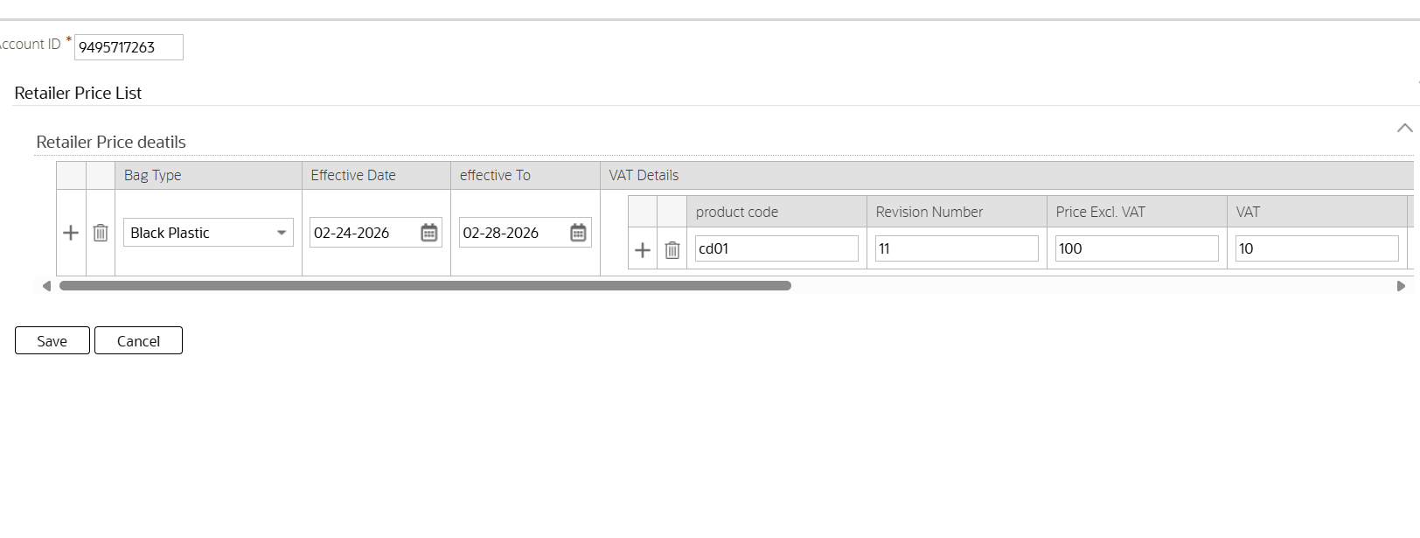
Mock Display UI
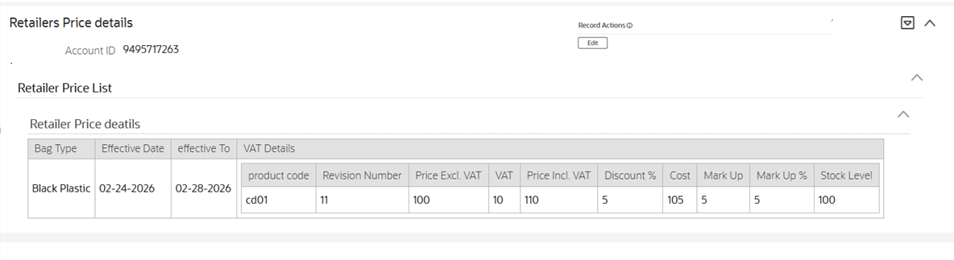

CM-MaintainItemPriceList
Maintain Item Price is an Extendable lookup BO used to Maintain the Effective dated and Revision Based Price details for the Items(Bags)
Property | Value
Business Object | CM-MaintainItemPriceList
Description | Maintain Item Price List
Maintenance Object | F1-EXT LKUP
Application Service | F1-DFLTS
Instance Control | Allow new instances
Schema | <schema name="schema">  <lookupValue label="Product Code" required="true" isPrimeKey="true" mapField="F1_EXT_LOOKUP_VALUE"/>  <bo suppress="true" isPrimeKey="true" fkRef="F1-BUSOB" mapField="BUS_OBJ_CD"/>  <description required="true" mapField="DESCR"/>  <overrideDescription suppress="blank" mapField="DESCR_OVRD"/>  <longDescription suppress="blank" mapField="DESCRLONG"/>  <lookupUsage required="true" dataType="lookup" default="F1AC" mapField="F1_EXT_LOOKUP_USAGE_FLG" lookup="F1_EXT_LOOKUP_USAGE_FLG"/>  <owner suppress="true" dataType="lookup" mapField="OWNER_FLG" lookup="OWNER_FLG"/>  <version suppress="true" dataType="number" mapField="VERSION"/>  <itemPriceList label="Item Details" type="group" mapXML="BO_DATA_AREA">  <bagList label="bagList" type="list">  <bagType label="Bag Type" dataType="lookup" isPrimeKey="true" lookup="CM_BAG_TYPE_FLG"/>  <revisionNumber label="Revison Number" type="group">  <vatData label="VAT Details" type="list">  <revNum label="Revison Number"/>  <effectiveDate mdField="EFFDT" dataType="date" isPrimeKey="true"/>  <endDate label="effective To" dataType="date" isPrimeKey="true"/>  <costPrice label="Cost Price"/>  <salePriceExclVAT label="Sale Price Excluding VAT"/>  <vatCode label="VAT Code"/>  <vatPercentage label="VAT Percentage"/>  <salePriceInclVAT label="Sale Price Including VAT"/>  </vatData>  </revisionNumber>  </bagList>  </itemPriceList>  </schema>

Field Name | Description
Main
Product Code | Mandatory. It is a Extendable lookup. It maps to the element Product Code in the Lookup Value
Bag Type | Mandatory. It is delivered to DC and It maps to the element Bag Type in the BO_DATA_AREA.
Revision number | It identifies the version of the item price list. It maps to the element Revision Number in the BO_DATA_AREA.
Cost price | Mandatory. Values must be greater than zero. It maps to the element Cost Price in the BO_DATA_AREA.
Sales Price Excluding VAT | Mandatory. Here the excluding value will be added tax (VAT) amount and must be greater than zero. It maps to the element Sale Price Excluding VAT in the BO_DATA_AREA.
VAT Code | Mandatory. Added value tax applicable for the product must/should be selected. It maps to the element VAT Code in the BO_DATA_AREA.
VAT Percentage | Here the percentage of added value tax is defined for selected VAT Code. It maps to the element VAT Percentage in the BO_DATA_AREA.
Sale Price Including VAT | Including VAT the price item will be sold. It maps to the element Sale Price Including VAT in the BO_DATA_AREA.
Effective From | Mandatory. The date which retailer price defines then it becomes effective. It maps to Effective From in the BO_DATA_AREA.
Effective To | Mandatory . this date should be later than the Effective Date From. It maps to Effective To in the BO_DATA_AREA.
Status | Current item price status (active/inactive). ). Maps to BO_DATA_AREA element status with Lookup Value – Active/Inactive

Whenever adding data or Updating data Validations needs to done on the product Effective Dates to avoid Overlapping and End date should not be prior to the From Date.

Maintain Item Price List Input Map
Input MAP should be rendered to maintain Item Price List of a specific customer/branch on top of the Item price. In this its custom interface hosts negotiated terms, like discount percentage, derived cost/ markup. And this design isolates branch-specific terms, preserving the integrity of the base item price list.
This portal is a Fact-based object and can be launch via the Retail Management Menu and the BO will contain the below elements
UI Mock Input
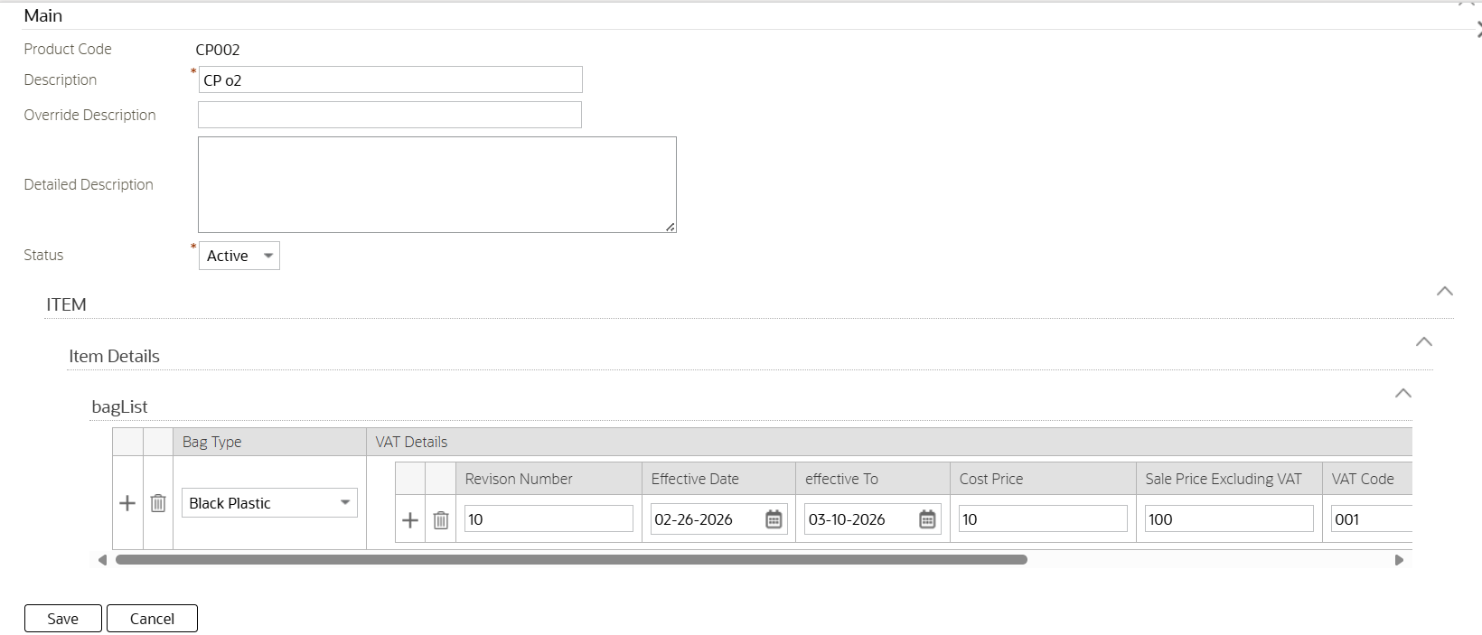

Mock Display UI
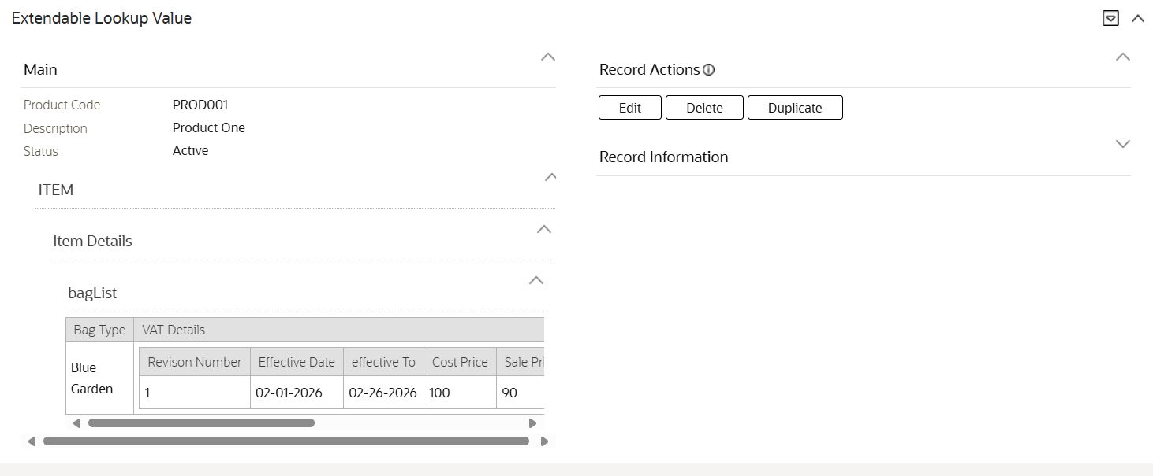

CM-OrderRetailManagement
This BO will be used to hold the Order data for Retail Management. This includes searchable characteristics for the order number, department, retailer code, branch code, and order status. These characteristics need to be protected and accessible only by DSW users. This BO also holds the retailer order number, customer account number, product variant details, order line items with product codes and quantities, delivery note reference, GRN reference, invoice authorization status, and order totals including subtotal excluding VAT, total discount, total VAT, and total amount including VAT.
Property | Value
Business Object | CM-OrderRetailManagement
Description | Order Retail Management
Maintenance Object | Fact
Application Service | TBD
Instance Control | Allow new instances
Schema | <schema xmlns:uiHint="http://oracle.com/ouafUIHints">  <factId suppress="input" mapField="FACT_ID" uiHint:visibleOn="displayMap" dataType="string"/>  <branchCode label="Branch Code" isPrimeKey="true" fkRef="ACCT" mapField="CHAR_VAL">  <row mapChild="F1_FACT_CHAR">  <CHAR_TYPE_CD is="C1-ACCT"/>  </row>  </branchCode>  <businessObject default="CM-OrderRetailMangement" mapField="BUS_OBJ_CD" uiHint:visibleOn="displayMap" dataType="string"/>  <uiHint:startSection mdField="F1_RECORD_ACTIONS_LBL" sectionColumn="right" visibleOn="displayMap"/>  <uiHint:includeMap map="CM-RetailOrderMgmtActions"/>  <uiHint:endSection/>  <rmMaintainOrder type="group" mapXML="FACT_DATA_AREA">  <maintainOrder label="Maintain Order" type="group">  <orderDate label="Order Date" dataType="date"/>  <retailerOrderNumber label="Retailer Order Number" dataType="string"/>  <caseId label="Case ID" fkRef="CASE" uiHint:visibleOn="displayMap" dataType="string"/>  </maintainOrder>  <productVariantDetails label="Product Variant Details" type="group">  <variant_1 label="Vairant-1" isPrimeKey="true" dataType="string"/>  <variant_2 label="Vairant-2" dataType="string"/>  <variant_3 label="Vairant-3" dataType="string"/>  </productVariantDetails>  <orderDetails label="Order Details" type="list">  <productCode label="Product Code" dataType="lookupBO" isPrimeKey="true" lookupBO="CM-MaintainItemPriceList"/>  <variant_1 label="Vairant-1" dataType="string"/>  <variant_2 label="Vairant-2" dataType="string"/>  <variant_3 label="Vairant-3" dataType="string"/>  <quantityOrdered label="Quantity Ordered" isPrimeKey="true" dataType="string"/>  <priceExclVat label="Price Excl. VAT" dataType="string"/>  <discountAmount label="Discount Amount" dataType="string"/>  <vat label="VAT" dataType="string"/>  <priceInclVat label="Price Incl. VAT" dataType="string"/>  <totalLineAmount label="Total Line Amount" dataType="string"/>  <requiredDate label="Required Date" dataType="date"/>  <stockLevel label="Stock Level" dataType="string"/>  <lineStatus label="Line Status" dataType="string"/>  <remark label="Remark" dataType="string"/>  </orderDetails>  <subTotal label="Sub Total" type="group">  <totalOrderQuantity label="Total Order Quantity" isPrimeKey="true" dataType="string"/>  <totalDiscount label="Total Discount" dataType="string"/>  <totalVat label="Total VAT" dataType="string"/>  <totalOrderAmountExclVat label="Total Order Amount Excl. VAT" dataType="string"/>  <totalOrderAmountInclVat label="Total Order Amount Incl. VAT" dataType="string"/>  </subTotal>  </rmMaintainOrder>  </schema>
Options | Display Map Service Script
 | Portal Navigation Option

Display UI:
The life cycle status Buttons needs to be rendered based on the Current BO status along with the Custom action Buttons such as calculate,Print and Print Itemlist
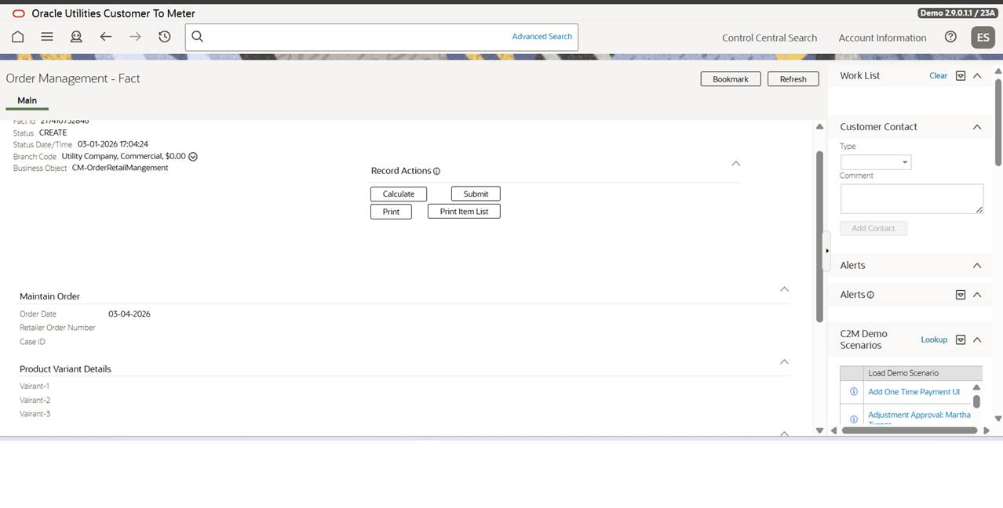
The Calculate Button Should Invoke the Editbale UI of the Fact Entity and Clicking on save should calculate the Total Line Item Amount on each line item level and calculate Total Order Quantity,Total Discount,Total VAT,Total Order Amount Excl. VAT,Total Order Amount Incl. VAT on the Order Level and update the Value to the Fact entity.
The Print and Print item list should call the BI Publisher by passing the Fact ID to render the Printable report.

CM-MaintainOrderInvoice
This BO will be used to hold the Maintain Invoice data for retail management. This includes searchable characteristics for the invoice number, account id, branch reference, order reference and invoice status. These characteristics need to be protected and accessible only by DSW users. This BO also holds the delivery note reference, GRN external reference, invoice line items with product codes, quantities delivered and pricing, invoice totals including subtotal excluding VAT, total discount, total VAT, total amount including VAT, currency, authorization status, and notes.
Property | Value
Business Object | CM-MaintainOrderInvoice
Description | Order Invoice Management
Maintenance Object | Fact
Application Service | TBD
Instance Control | Allow new instances
Schema | <schema>  <factId mapField="FACT_ID" dataType="string"/>  <businessObject default="CM-MaintainOrderInvoice" mapField="BUS_OBJ_CD" dataType="string"/>  <maintainOrderInvoice type="group" mapXML="FACT_DATA_AREA">  <orderInvoice label="Order Invoice" type="group">  <department label="Department" dataType="string"/>  <invoiceNumber label="Invoice Number" dataType="string"/>  <invoiceDate label="invoice Date" dataType="date" isPrimeKey="true"/>  <status label="Status" isPrimeKey="true" dataType="string"/>  <orderNumber label="Order Number" isPrimeKey="true" dataType="string"/>  <orderDate label="Order Date" dataType="date" isPrimeKey="true"/>  <accountId label="Account ID" isPrimeKey="true" dataType="string"/>  <retailerCode label="Retailer Code" isPrimeKey="true" dataType="string"/>  <branchCode label="Branch Code" isPrimeKey="true" fkRef="ACCT" dataType="string"/>  <deliveryAddress label="Delivery Address" dataType="string"/>  <notes label="Notes" isPrimeKey="true" dataType="string"/>  </orderInvoice>  <productVariantDetails label="Product Variant Details" type="list">  <variant_1 label="Variant-1" isPrimeKey="true" dataType="string"/>  <variant_2 label="Variant-2" dataType="string"/>  <variant_3 label="Variant-3" dataType="string"/>  </productVariantDetails>  <invoiceDetails label="Invoice Details" type="group">  <lineNo label="Line No" isPrimeKey="true" dataType="string"/>  <productCode label="Product Code" isPrimeKey="true" dataType="string"/>  <variant_1 label="Variant-1" dataType="string"/>  <variant_2 label="Variant-2" dataType="string"/>  <variant_3 label="Variant-3" dataType="string"/>  <quantityOrdered label="Quantity Ordered" isPrimeKey="true" dataType="string"/>  <priceExclVat label="Price Excl. VAT" dataType="string"/>  <discountAmount label="Discount Amount" dataType="string"/>  <vat label="VAT" dataType="string"/>  <priceInclVat label="Price Incl. VAT" dataType="string"/>  <totalLineAmount label="Total Line Amount" dataType="string"/>  <requiredDate label="Required Data" dataType="date"/>  <stockLevel label="Stock Level" dataType="string"/>  <lineTotal label="Line Total" dataType="string"/>  <remark label="Remark" dataType="string"/>  </invoiceDetails>  <subTotal label="Sub Total" type="list">  <totalInvoiceQuantity label="Total Invoice Quantity" isPrimeKey="true" dataType="string"/>  <totalDiscount label="Total Discount" dataType="string"/>  <totalVat label="Total VAT" dataType="string"/>  <totalInvoiceAmountExclVat label="Total Invoice Amount Excl. VAT" dataType="string"/>  <totalInvoiceAmountInclVat label="Total Invoice Amount Incl. VAT" dataType="string"/>  </subTotal>  </maintainOrderInvoice>  </schema>
Options | Display Map Service Script
 | Portal Navigation Option

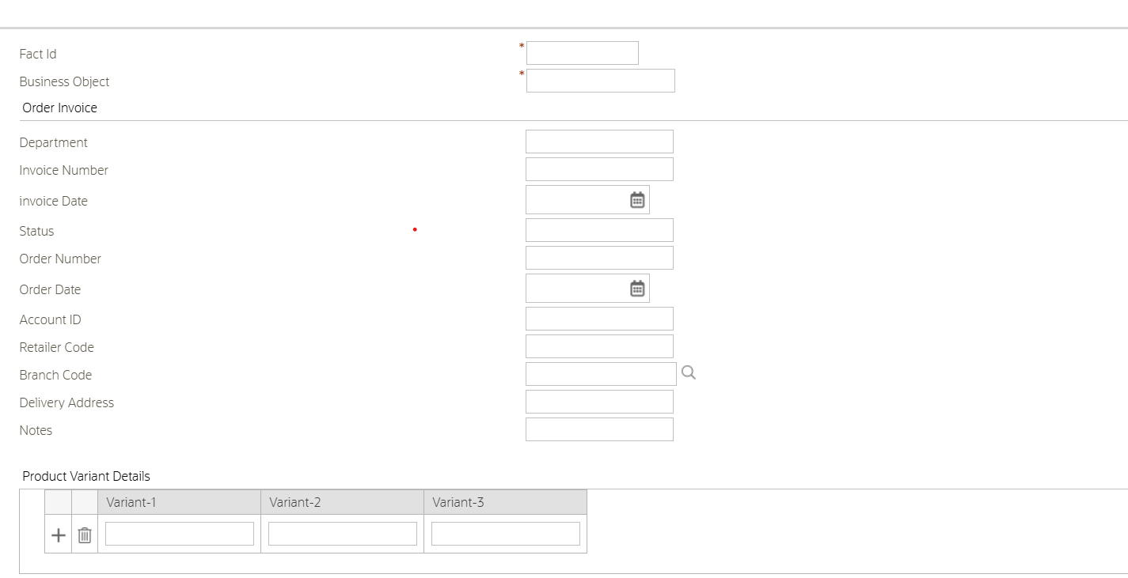
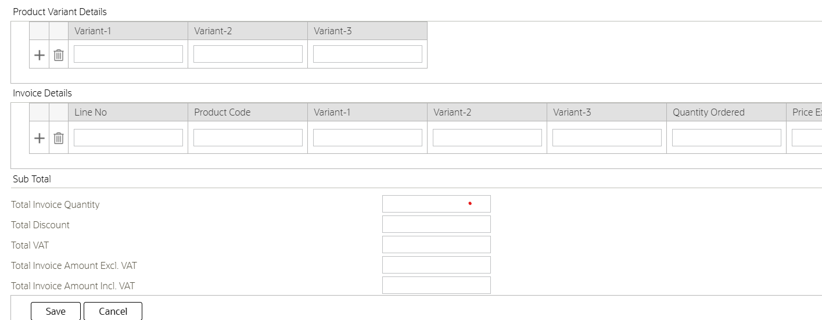

CM-MaintainDeliveryNote
This BO will be used to hold the Delivery Note data for retail management. This includes searchable characteristics for the delivery note number, order reference, route reference, and delivery status. These characteristics need to be protected and accessible only by DSW users. This BO also holds the vehicle registration, delivery person details, required delivery date, actual delivery date, GRN external reference, proof of delivery capture status, delivery line items with planned and delivered quantities, receiver name, and optional return reference linkbacks.
Property | Value
Business Object | CM-MaintainDeliveryNote
Description | Maintain Delivery Note
Maintenance Object | Fact
Application Service | TBD
Instance Control | Allow new instances
Schema | <schema>  <factId mapField="FACT_ID" dataType="string"/>  <businessObject default="CM-MaintainDeliveryNote" mapField="BUS_OBJ_CD" dataType="string"/>  <maintainDeliveryNote type="group" mapXML="FACT_DATA_AREA">  <deliveryNote label="delivery Note" type="group">  <deliveryNoteNBR label="Delivery Note Number" dataType="string"/>  <orderReference label="Order reference" dataType="string"/>  <reqdeliveryDate label="Requested Delivery Date" dataType="date" isPrimeKey="true"/>  <deliveryDate label="Delivery Date" dataType="date" isPrimeKey="true"/>  <vehicleRegistration label="Vehicle Registration" isPrimeKey="true" dataType="string"/>  <deliveryPerson label="Delivery Person" isPrimeKey="true" dataType="string"/>  <deliveryContact label="Delivery Contact" isPrimeKey="true" dataType="string"/>  <goodsReceivedNoteNBR label="Goods Received Note NBR" isPrimeKey="true" dataType="string"/>  <routeReference label="Route Reference" isPrimeKey="true" dataType="string"/>  <deliveryStatus label="Delivery Status" dataType="string"/>  <attachments label="Attachments" isPrimeKey="true" dataType="string"/>  </deliveryNote>  <deliveryDetails label="Delivery Details" type="list">  <sequenceNumber label="Sequence Number" isPrimeKey="true" dataType="string"/>  <productCode label="Product Code" isPrimeKey="true" dataType="string"/>  <quantityPlanned label="Quantity Planned" isPrimeKey="true" dataType="string"/>  <quantityDelivered label="Quantity Delivered" dataType="string"/>  <receiverName label="Receiver Name" dataType="string"/>  <proofOfDeliveryCaptured label="Proof of Delivery Captured" dataType="string"/>  </deliveryDetails>  </maintainDeliveryNote>  </schema>
Options | Display Map Service Script
 | Portal Navigation Option

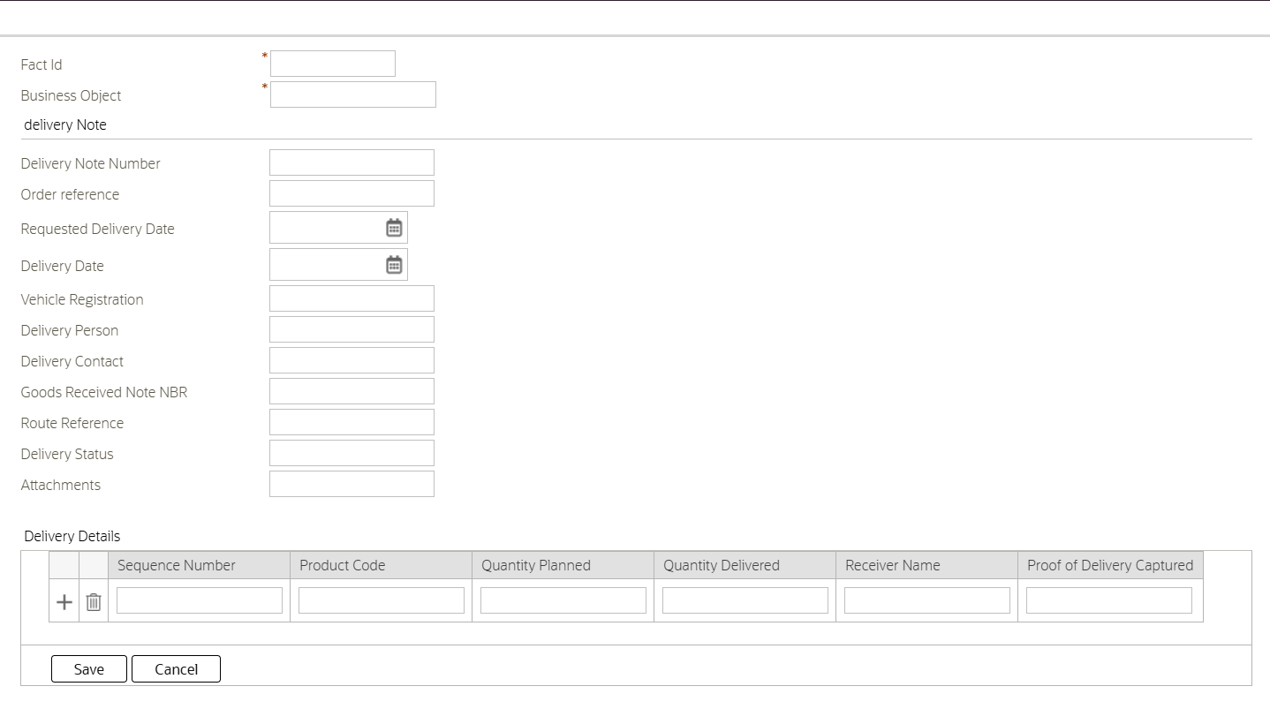

BO Lifecycle

Maintain Orders

Status | Description | Sequence | Status Condition | Transitory State | Alert | Next status
CREATE | Create | 10 | Initial | No | Display | - SUBMITTED
Required Characteristics
Comment

Status | Description |  | Sequence | Status Condition | Transitory State | Alert | Next status
SUBMITTED | Submitted |  | 20 | Interim | No | Display | - HOLD  - ORDERED
Required Characteristics
Comment
System Event | Seq. | Algorithm
Enter Processing | 10
Exit processing | 10

Status | Description |  | Sequence | Status Condition | Transitory State | Alert | Next status
HOLD | Hold |  | 30 | Interim | No | Display | - ORDERED
Required Characteristics
Comment
System Event | Seq. | Algorithm
Enter Processing | 10
Exit processing | 10

Status | Description |  | Sequence | Status Condition | Transitory State | Alert | Next status
ORDERED | Ordered |  | 40 | Interim | No | Display | - SHORTCLS  - HOLD  - CANCELLED
Required Characteristics
Comment
System Event | Seq. | Algorithm
Enter Processing | 10
 | 20
Exit processing | 10

Status | Description |  | Sequence | Status Condition | Transitory State | Alert | Next status
SHORTCLS | On Hold |  | 50 | Interim | No | Display | - CLOSE
Required Characteristics
Comment
System Event | Seq. | Algorithm
Enter Processing | 10
Exit processing | 10

Status | Description |  | Sequence | Status Condition | Transitory State | Alert | Next status
CANCELLED | Captured |  | 60 | Interim | No | Display | - CLOSE
Required Characteristics
Comment
System Event | Seq. | Algorithm
Enter Processing | 10
Exit processing | 10

Status | Description | Sequence | Status Condition | Transitory State | Alert | Next status
CLOSED | Closed | 70 | Final | No
Required Characteristics
Comment

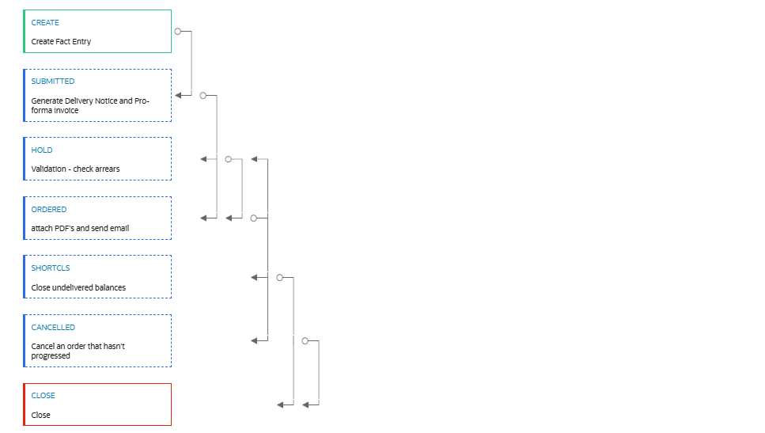

Maintain Invoice

Status | Description | Sequence | Status Condition | Transitory State | Alert | Next status
FRESH | Fresh | 10 | Initial | No | Display | - L1-APPRV
Required Characteristics
Comment

Status | Description |  | Sequence | Status Condition | Transitory State | Alert | Next status
L1-APPRV | L1-Approval |  | 20 | Interim | No | Display | - FINAL
Required Characteristics
Comment
System Event | Seq. | Algorithm
Enter Processing | 10
 | 20
Exit processing | 10

Status | Description |  | Sequence | Status Condition | Transitory State | Alert | Next status
FINAL | Approved |  | 30 | Interim | No | Display | - REJECTED
Required Characteristics
Comment
System Event | Seq. | Algorithm
Enter Processing | 10
Exit processing | 10

Status | Description |  | Sequence | Status Condition | Transitory State | Alert | Next status
REJECTED | Rejected |  | 40 | Final | No | Display
Required Characteristics
Comment
System Event | Seq. | Algorithm
Enter Processing | 10
Exit processing | 10

Maintain Delivery Note

Status | Description | Sequence | Status Condition | Transitory State | Alert | Next status
DRAFT | Draft | 10 | Initial | No | Display | - ISSUED
Required Characteristics
Comment

Status | Description |  | Sequence | Status Condition | Transitory State | Alert | Next status
ISSUED | Issued |  | 20 | Interim | No | Display | - COMPLETED
Required Characteristics
Comment
System Event | Seq. | Algorithm
Enter Processing | 10
 | 20
Exit processing | 10

Status | Description |  | Sequence | Status Condition | Transitory State | Alert | Next status
COMEPETED | Completed |  | 30 | Interim | No | Display | - CANCELLED
Required Characteristics
Comment
System Event | Seq. | Algorithm
Enter Processing | 10
Exit processing | 10

Status | Description |  | Sequence | Status Condition | Transitory State | Alert | Next status
CANCELLED | Cancelled |  | 40 | Final | No | Display
Required Characteristics
Comment
System Event | Seq. | Algorithm
Enter Processing | 10
Exit processing | 10

Zone

CM-RTLMGMACT
Property | Value
Zone | CM-RTLMGMACT
Zone Type | Explicit Object Map
Description | Retail Management Account
Application Service | CILCACCP
Ui Map | map='CM_RetailManagementDisplay'
Zone Visibility Service Script | ss='CM-ZoneAlwVI' output=shouldShowZone
display Object | bo='CM_RetailManagement'
XML Parameter 1 | Name=ACCT_ID targetPath=accountId

CMRTPRRICEMG
Property | Value
Zone | CMRTPRRICEMG
Zone Type | Explicit Object Map
Description | Retail Price Details
Application Service | Account
Ui Map | map='CM-RetialAccountPriceMgmtDisp'
Zone Visibility Service Script | ss='CM-ZoneBrcVl' output=shouldShowZone
display Object | bo='CM-RetialAccountPriceMgmt'
XML Parameter 1 | name=ACCT_ID targetPath=accountId

Portal
Create Account Retail Management to Main Retail and Retailers Price details.
Include the Zone field in the portal to allow users to search, add, or update Blocks based on Zone.

CMACTRTM
Property | Value
Portal | CMACTRTM
Description | Account Retail Management
Type | Standalone Portal
Application Service
Zone 1 | C1-ACMGMQRY
Zone 2 | CM-RTLMGMACT
Zone 3 | CMRTPRRICEMG

Note: C1-ACMGMQRY can be Duplicated/customized to CM zone to adjust the Input filter, broadcast and output displays for the Account Retail management.

CMORDMGM
Create Order Management Portal for Adding the Fact based Order Management Entity in the Portal action option(Add order) and for Searching the Order Fact entry using the Branch Account ID, Creation Date, Completion Date,Fact Status which needs to Navigate the Fact Entity (Bo - CM-OrderRetailManagement).
Order management Portal:
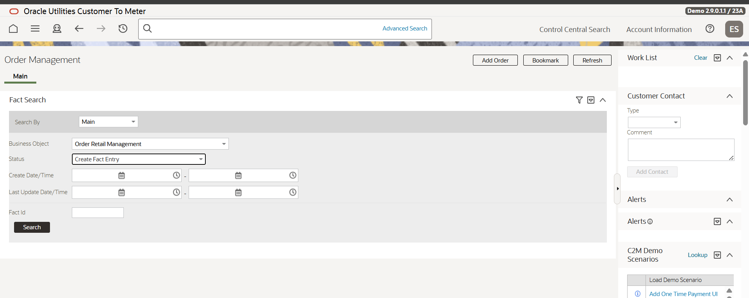

Add order Button Click should invoke the Order management UI for creating the Fact Entry.
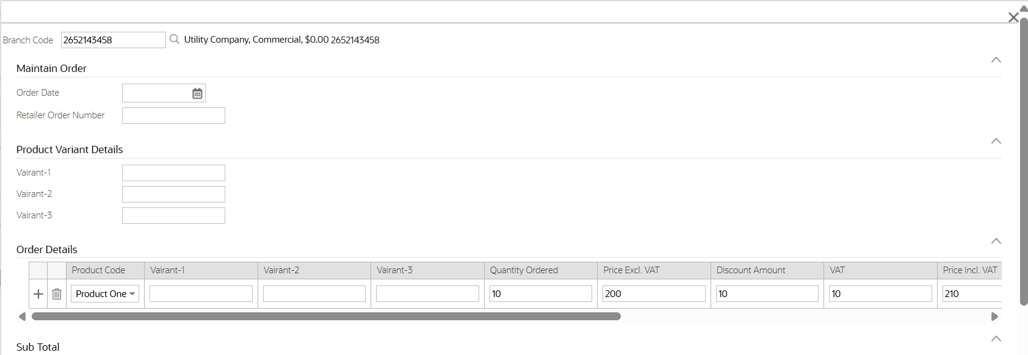

After choosing the Product code the Price Details such as Price Excl Vat, Vat Amount, Inclusive Vat amount should be auto populated from the Extendable lookup (CM-MaintainItemPriceList) or if the Branch account has Special Retail Price (CM-RetailAccountPriceMgmt).
Search Options output:
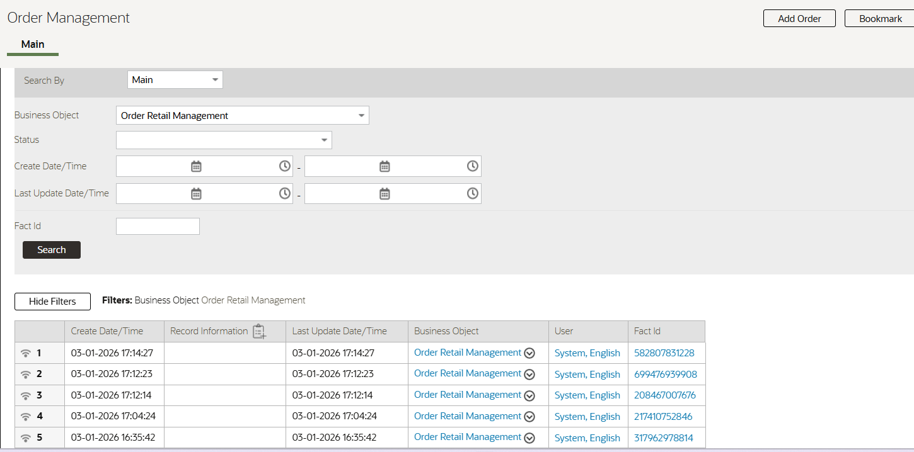
Clicking on Fact Id should take the Relevant Fact Ids’s BO navigation Portal. Similarly order can be searched using the Account Id(Branch) its created
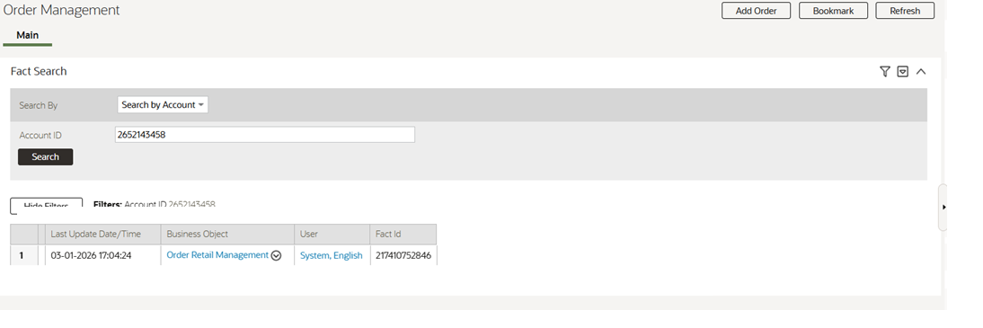

CMINVMGM
Create Invoice Management Portal for Searching the Order Fact entry using the Branch Account ID,Order Id, Creation Date, Completion Date,Fact Status which needs to Navigate the Fact Entity (CM-MaintainOrderInvoice).

Menu
Upon generating the Portal, the system will automatically create the required navigation options and associated keys.
These keys must be used to add the following submenus into the main menu to facilitate access to the maintenance modules:
- Retail Management
Selecting any of the above menu option system should invoke the respective maintenance portal. When a user clicks on any of this option, a Query Portal should be displayed to view existing entries.
Upon selecting ADD, an Input Map should be presented to allow the user to add or update details. These menu items and associated functionalities must be restricted to authorized users only.
Mock UI:
Account Should be searched with the Retailer Code or branch Code Characteristics type and on Broad cast/search of the account ID Maintain Retailers and Retailers price list zone should be displayed.
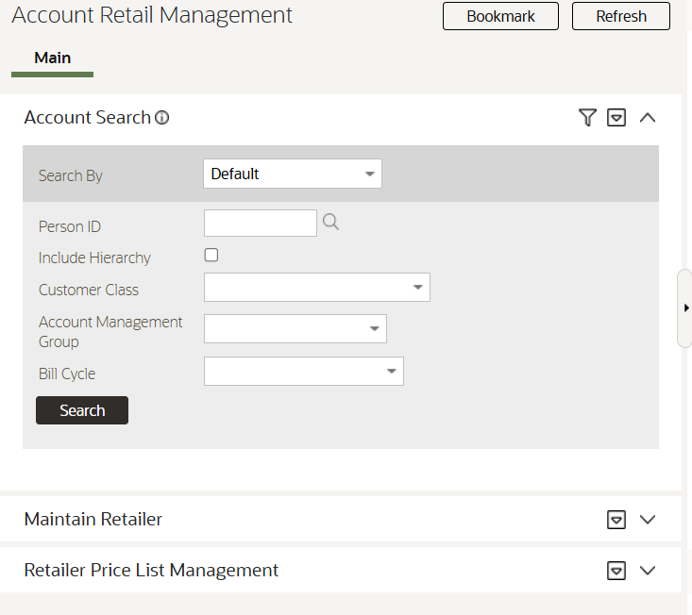
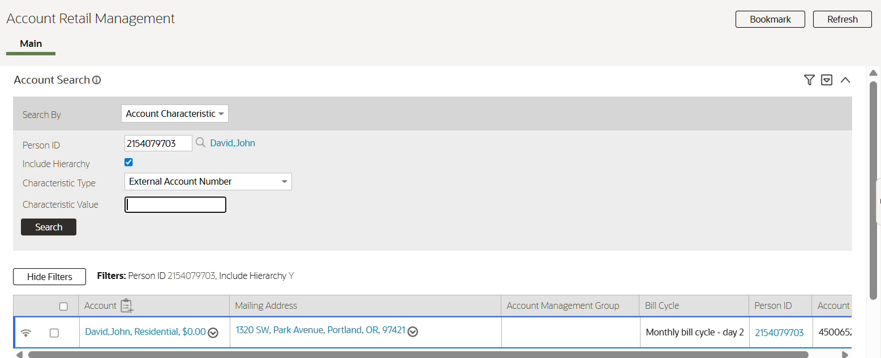

Script

CMActRetMain
This BPA will be used to Maintain the Retails management Account and validations for Changing the Branch Status and Updating/Removing the Branch char.
The chars (CMBRCHCD – Branch Code ), (CMRTATID – Retailer account ID) will be added/updated/removed on the accounts during the updates. It is assumed that one branch will linked to one Retailer at a time.
Property | Value
Script | CMActRetMain
Description | Retail Management Account
Script Type | BPA script
Application Service | F1-DFLTS
Script as text | move "$accountId" to $boPrimeKey;  //move "$accountId" to "map_schema/boGroup/accountId";  move 'map_schema/accountId' to $boPrimeKeyXpath;  if("$action='UPD'")  move "$acctId" to "CM_RetailManagement/accountId";  invokeBO 'CM_RetailManagement' using "CM_RetailManagement" for read;  end-if;  generateBOEditMap 'CM_RetailManagement' using "CM_RetailManagement";  //move "map_schema/accountId" to "CM_RetailManagement/accountId";  //invokeBO 'CM_RetailManagement' using "CM_RetailManagement" for read;  invokeBO 'CM_RetailManagement' using "CM_RetailManagement" for update;  //For each of the Branches updated/removed the chars (CMBRCHCD – Branch Code), (CMRTATID – Retailer account ID) will be added/updated/removed

CMActRtlPrcM
Property | Value
Script | CMActRtlPrcM
Description | Account Retail Price Management
Script Type | BPA script
Algorithm Entity
Application Service | F1-DFLTS
Script as text

CM-ZoneBrcVl
Property | Value
Script | CM-ZoneBrcVI
Description | Zone Visibility - True if the account is Branch and active
Script Type | Service script
Algorithm Entity
Application Service | F1-DFLTS
Script as text | 1: label "This script will determine whether to display the Retailer Price Management Zone or not";  10: edit data  // Initialize values  //Return true if Account is a Branch account(CMBRCHCD - Branch Code ) and the account is active for the Retailer Mapped (CMRTATID - Retailer account ID) has this account ID as Active in the account Data area  move 'true' to "parm/shouldShowZone";  end-edit;

CMOrdMgmMtAt
Property | Value
Script | CMOrdMgmMtAt
Description | order magt action service script
Script Type | Service script
Algorithm Entity
Application Service | C1SITASK
Script as text | 10: edit data  if ("parm/factId = $BLANK")  terminate;  end-if;  end-edit;  20: edit data  move 'F1-FACT' to "F1-DetermineBo/input/mo";  move "parm/factId" to "F1-DetermineBo/input/pkValue1";  invokeBS 'F1-DetermineBo' using "F1-DetermineBo";  move "F1-DetermineBo/output/bo" to "parm/bo";  end-edit;  30: edit data  invokeBO "F1-DetermineBo/output/bo" using "parm" for read;  end-edit;  40: edit data  if ("parm/boStatus != $BLANK")  move "parm/factId" to "F1-RetrieveNextStates/input/pkValue1";  move "F1-DetermineBo/output/bo" to "F1-RetrieveNextStates/input/bo";  move "F1-DetermineBo/output/boStatus" to "F1-RetrieveNextStates/input/boStatus";  invokeBS 'F1-RetrieveNextStates' using "F1-RetrieveNextStates";  for ($state in "F1-RetrieveNextStates/output/states")  move "$state/default" to "parm/output/+states/default";  move "$state/boStatus" to "parm/output/states[last()]/boStatus";  move "$state/boTransitory" to "parm/output/states[last()]/boTransitory";  move "$state/boNextStatusLabel" to "parm/output/states[last()]/boNextStatusLabel";  move "$state/access" to "parm/output/states[last()]/access";  move "$state/boTransitionCondition" to "parm/output/states[last()]/boTransitionCondition";  end-for;  end-if;  end-edit;

CM_RMMOVALID
Property | Value
Script | CM_RMMOVALID
Description | Arrear Validation/Check
Script Type | Plug-in script
Algorithm Entity | Package – Criteria Field
Application Service | <<>>
Script as text | - Retrieve Account ID  - Check the arrears  - If arrears exist proceed to status HOLD  - If arrears do not exist proceed to ORDERED

CM_RMBBRTORD
Property | Value
Script | CM_RMBBRTORD
Description | Blue Bag – Retail Order Case
Script Type | Plug-in script
Algorithm Entity | Package – Criteria Field
Application Service | <<>>
Script as text | - Create the given case type with the valid inputs

CM_RMPROFINV
Property | Value
Script | CM_RMPROFINV
Description | Pro-forma Invoice
Script Type | Plug-in script
Algorithm Entity | Package – Criteria Field
Application Service | <<>>
Script as text | - Create Pro-forma Invoice

CM_RMMROVALD
Property | Value
Script | CM_RMMROVALD
Description | Validate Attachments
Script Type | Plug-in script
Algorithm Entity | Package – Criteria Field
Application Service | <<>>
Script as text | - Admin validates intake (PO/portal ref, Delivery Notice, Pro-forma).

CM_RMMROMAIL
Property | Value
Script | CM_RMMROMAIL
Description | Depot Email
Script Type | Plug-in script
Algorithm Entity | Package – Criteria Field
Application Service | <<>>
Script as text | - Depot Email to notify depot/region

CM_RMMRVALID
Property | Value
Script | CM_RMMRVALID
Description | Validate return attachments
Script Type | Plug-in script
Algorithm Entity | Package – Criteria Field
Application Service | <<>>
Script as text | - Validate links to Delivery Note/Invoice; check quantities

CM_RMOINCALC
Property | Value
Script | CM_RMOINCALC
Description | Calculate Sub Total
Script Type | Plug-in script
Algorithm Entity | Package – Criteria Field
Application Service | <<>>
Script as text | - Validate links to Delivery Note/Invoice; check quantities

CM_OrdMgmMt
Calculates the order amounts including product prices, discount amounts, VAT, and total invoice amounts (excl. and incl. VAT) for all line items in the order before submission. Invokes the BO 'CM-OrderRetailMangement' using the CALCULATE action.
Property | Value
Script | CM_OrdMgmMt
Description | Order Management fact Maintain
Script Type | BPA script
Application Service | F1-DFLTS
Script as text | If action =’ADD’  generateBOEditMap 'CM-OrderRetailMangement' using "CM-OrderRetailMangement";  invokeBO 'CM-OrderRetailMangement' using "CM-OrderRetailMangement" for add;  if action =’CALCULATE’  update the Price Details based on the Product code mapping with extendable lookup/Branch Specific Price Details

CM_PrintOrdr
Property | Value
Script | CM-PrintOrdr
Description | Print Order
Script Type | BPA script
Application Service | F1-DFLTS
Script as text | Invoke BI Publisher for Order Print

CM_PrnItmLst
Property | Value
Script | CM-PrnItmLst
Description | Print Item List
Script Type | BPA script
Application Service | F1-DFLTS
Script as text | Invoke BI Publisher for Item Print Details

Algorithm Type

CM_RMMOVALID
Field Name | Field Value
Algorithm type | CM_RMMOVALID
Description | check arrears and decide which status to proceed.
Detailed Description | The purpose of this algorithm is that it takes 2 status inputs and checks the arrears and decides what to do.  If arrears exist - status 1 (HOLD)  If arrears doesn't exist - status 2 (ORDERED)
Algorithm Entity | Business Object Status – Enter
Program Type | Plug-in Script
Script | CM_RMMOVALID
Algorithm Parameter | Required
Status-1 | HOLD
Status-2 | ORDERED

CM_RMBBRTORD
Field Name | Field Value
Algorithm type | CM_RMMOVALID
Description | Blue Bags Case
Detailed Description | Blue Bags - Retail Order Case
Algorithm Entity | Business Object Status – Enter
Program Type | Plug-in Script
Script | CM_RMBBRTORD
Algorithm Parameter | Required
Blue Bags Case type code | CM-RMBBCSP

CM_RMPROFINV
Field Name | Field Value
Algorithm type | CM_RMPROFINV
Description | Pro-forma Invoice
Detailed Description | Create Pro-forma Invoice and send pro-forma PDF email.
Algorithm Entity | Business Object Status – Enter
Program Type | Plug-in Script
Script | CM_RMPROFINV
Algorithm Parameter | Required
FACT BO | CM-MaintainOrderInvoice

CM_RMMROVALD
Field Name | Field Value
Algorithm type | CM_RMMROVALD
Description | Validate Attachments
Detailed Description | Admin validates intake (PO/portal ref, Delivery Notice, Pro-forma).
Algorithm Entity | Business Object Status – Enter
Program Type | Plug-in Script
Script | CM_RMMROVALD
Algorithm Parameter | Required

CM_RMDPOMAIL
Field Name | Field Value
Algorithm type | CM_RMDPOMAIL
Description | Depot Email
Detailed Description | Depot mail
Algorithm Entity | Business Object Status – Enter
Program Type | Plug-in Script
Script | CM_RMDPOMAIL
Algorithm Parameter | Required

CM_RMMRVALID
Field Name | Field Value
Algorithm type | CM_RMMRVALID
Description | Validate return attachments
Detailed Description | Validate links to Delivery Note/Invoice; check quantities
Algorithm Entity | Business Object Status – Enter
Program Type | Plug-in Script
Script | CM_RMMRVALID
Algorithm Parameter | Required

Algorithms

CM_RMMOVALID
Field | Value
Algorithm | CM_RMMOVALID
Description | check arrears and decide which status to proceed.
Algorithm Type | CM_RMMOVALID
Algorithm Parameters
Fact BO | CM-OrderRetailMangement

CM_RMBBRTORD
Field | Value
Algorithm | CM_RMMOVALID
Description | Blue Bags Case
Algorithm Type | CM_RMMOVALID
Soft Parameters
Blue Bags Case type code | CM-RMBBCSP

CM_RMPROFINV
Field | Value
Algorithm | CM_RMPROFINV
Description | Create Pro-forma Invoice and send pro-forma PDF email.
Algorithm Type | CM_RMPROFINV
Algorithm Parameters
Fact BO | CM-MaintainOrderInvoice

CM_RMMROVALD
Field | Value
Algorithm | CM_RMMROVALD
Description | Admin validates intake (PO/portal ref, Delivery Notice, Pro-forma).
Algorithm Type | CM_RMMROVALD
Soft Parameters
Document Intake | PO/Portal ref
 | Delivery Notice
 | Pro-forma

CM_RMMROMAIL
Field | Value
Algorithm | CM_RMMROMAIL
Description | Depot mail to notify depot/region
Algorithm Type | CM_RMDPOMAIL

CM_RMMRVALID
Field | Value
Algorithm | CM_RMMRVALID
Description | Validate links to Delivery Note/Invoice; check quantities
Algorithm Type | CM_RMMRVALID
Soft Parameters
Document Intake | Delivery Note
 | Invoice

CM_RMMRDMAIL
Field | Value
Algorithm | CM_RMMRDMAIL
Description | Depot email with return note PDF
Algorithm Type | CM_RMDPOMAIL

UI MAP

CM-RetialAccountPriceMgmtDisp
CM-RetailManagementDisplay – the UI map will be used to display the Retail Account Detail and its branch details and Edit button will be available which will invoke the BO to display the details for Edit.

Property | Value
UI Map | CM-RetailAccountPriceMgmtDisp
UI Map Type | XHTML Document
Description | Retail Price Management Display
HTML Editor | <!DOCTYPE html PUBLIC "-//W3C//DTD XHTML 1.0 Strict//EN" "http://www.w3.org/TR/xhtml1/DTD/xhtml1-strict.dtd">  <html class="scrollRepaintFix">  <head>  <link rel="stylesheet" type="text/css" href="cisDisabled.css" />  <script>  function processButtonClick(action) {  var root = xmlData.documentElement;  var bo = OraDomElementHelper.getText(root.selectSingleNode('bo'));  var values= {action: action, bo: bo};  oraRunScriptWithValues('CMActRtlPrcM', values);  }  </script>  </head>  <body class="oraZoneMap">  <input id="EDIT" oraMdLabel="EDIT_LBL" class="oraButton" type="button" style="float:left;" onClick="processButtonClick('UPD');" />  <div>  <label oraLabel="accountId" for="accountId" />  <span oraField="accountId" id="accountId" />  </div>  <div class="oraGridDiv" id="retailerBranch_retailerBranchList">  <table cellspacing="2" oraMdLabel="GENERIC_SUMMARY" oraList="retailerBranch/retailerBranchList" onResize="if (this.clientWidth &gt; this.parentNode.clientWidth) { this.parentNode.className += ' oraGridDivScroll';};">  <thead>  <tr>  <th class="oraGridColumnHeader" oraLabel="branchCode" nowrap="nowrap" scope="col" />  <th class="oraGridColumnHeader" nowrap="nowrap" oraLabel="bagList" />  </tr>  </thead>  <tbody>  <tr>  <td class="oraNormal oraDisplayCell" scope="row" oraField="branchCode" />  <td class="oraDisplayCell oraEmbeddedTable" nowrap="nowrap">  <table cellspacing="2" oraMdLabel="GENERIC_SUMMARY" oraList="bagList" onResize="if (this.clientWidth &gt; this.parentNode.clientWidth) { this.parentNode.className += ' oraGridDivScroll';};">  <thead>  <tr>  <th class="oraGridColumnHeader" oraLabel="bagType" nowrap="nowrap" scope="col" />  <th class="oraGridColumnHeader" oraLabel="effectiveDate" nowrap="nowrap" scope="col" />  <th class="oraGridColumnHeader" oraLabel="endDate" nowrap="nowrap" scope="col" />  <th class="oraGridColumnHeader" nowrap="nowrap" oraLabel="revisionNumber/vatData" />  </tr>  </thead>  <tbody>  <tr>  <td class="oraNormal oraDisplayCell" scope="row" oraField="bagType" />  <td class="oraNormal oraDisplayCell" scope="row" oraField="effectiveDate" />  <td class="oraNormal oraDisplayCell" scope="row" oraField="endDate" />  <td class="oraDisplayCell oraEmbeddedTable" nowrap="nowrap">  <table cellspacing="2" oraMdLabel="GENERIC_SUMMARY" oraList="revisionNumber/vatData" onResize="if (this.clientWidth &gt; this.parentNode.clientWidth) { this.parentNode.className += ' oraGridDivScroll';};">  <thead>  <tr>  <th class="oraGridColumnHeader" oraLabel="productCode" nowrap="nowrap" scope="col" />  <th class="oraGridColumnHeader" oraLabel="revNum" nowrap="nowrap" scope="col" />  <th class="oraGridColumnHeader" oraLabel="costPrice" nowrap="nowrap" scope="col" />  <th class="oraGridColumnHeader" oraLabel="vatPer" nowrap="nowrap" scope="col" />  <th class="oraGridColumnHeader" oraLabel="costIncVat" nowrap="nowrap" scope="col" />  <th class="oraGridColumnHeader" oraLabel="discountPrice" nowrap="nowrap" scope="col" />  </tr>  </thead>  <tbody>  <tr>  <td class="oraNormal oraDisplayCell" scope="row" oraField="productCode" />  <td class="oraNormal oraDisplayCell" oraField="revNum" />  <td class="oraNormal oraDisplayCell" oraField="costPrice" />  <td class="oraNormal oraDisplayCell" oraField="vatPer" />  <td class="oraNormal oraDisplayCell" oraField="costIncVat" />  <td class="oraNormal oraDisplayCell" oraField="discountPrice" />  </tr>  </tbody>  </table>  </td>  </tr>  </tbody>  </table>  </td>  </tr>  </tbody>  </table>  </div>  </body>  <xml style="display:none;">  <root>  <accountId>3243395299</accountId>  </root>  </xml>  </html>

CM-RetialOrderMgmtActions
CM-RetailOrderMgmtActions – the UI map will be used to display the action buttons for the Order Retail Management fact. Calculate, Submit and Cancel buttons will be available which will invoke the BPA scripts CM-OrdMgmMt, CM-PrintOrdr and CM-PrnItmLst respectively to perform the corresponding actions on the BO CM-OrderRetailMangement.
Property | Value
UI Map | CM-RetailOrderMgmtActions
UI Map Type | XHTML Document
Description | Retail Management Task Actions
HTML Editor | <script type="text/javascript">  /* <![CDATA[ */  function getAction() {  id('pkVal1').value = id('factId').value;  oraInvokeSS('CMOrdMgmMtAt','nextStates');  }  function processButtonClick (actionValue,index) {  var path = 'nextStates/output/states[' + index +']/boStatus';  var actions = {action: actionValue};  oraRunScriptWithValues('CM_OrdMgmMt', actions, 'factId', 'bo', path);  }  function processCalculate() {  //Open the Input map of the fact BO and calculate the amounts and update the BO.  var actions = {action: 'CALCULATE'};  oraRunScriptWithValues('CM_OrdMgmMt', actions, 'factId', 'bo', path);  }  /* ]]> */  </script>  <div>  <input id="CALCULATE" oraMdLabel="CALCULATE_LBL" class="oraButton" type="button" style="float:left;" onClick="processCalculate();" />  </div>  <div>  <input id="PRINT ORDER" oraMdLabel="PRINT_LBL" class="oraButton" type="button" style="float:left;" />  </div>  <div>  <input id="PRINT_ITEM_LIST" oraMdLabel="PRINT_LBL" class="oraButton" type="button" style="float:left;" />  </div>  <div id="actionSection">  <div oraAfterLoad="getAction();">  <input id="TRANSITION_1" oraMdLabel="TRANSITION_1_LBL" class="oraButton" type="button" style="float:left; display:none" onClick="processButtonClick('TRANSITION',1);"/>  <input id="TRANSITION_2" oraMdLabel="TRANSITION_2_LBL" class="oraButton" type="button" style="float:left; display:none" onClick="processButtonClick('TRANSITION',2);"/>  <input id="TRANSITION_3" oraMdLabel="TRANSITION_3_LBL" class="oraButton" type="button" style="float:left; display:none" onClick="processButtonClick('TRANSITION',3);"/>  <input id="TRANSITION_4" oraMdLabel="TRANSITION_4_LBL" class="oraButton" type="button" style="float:left; display:none" onClick="processButtonClick('TRANSITION',4);"/>  <input id="TRANSITION_5" oraMdLabel="TRANSITION_5_LBL" class="oraButton" type="button" style="float:left; display:none" onClick="processButtonClick('TRANSITION',5);"/>  <input id="TRANSITION_6" oraMdLabel="TRANSITION_6_LBL" class="oraButton" type="button" style="float:left; display:none" onClick="processButtonClick('TRANSITION',6);"/>  <input id="TRANSITION_7" oraMdLabel="TRANSITION_7_LBL" class="oraButton" type="button" style="float:left; display:none" onClick="processButtonClick('TRANSITION',7);"/>  <input id="TRANSITION_8" oraMdLabel="TRANSITION_8_LBL" class="oraButton" type="button" style="float:left; display:none" onClick="processButtonClick('TRANSITION',8);"/>  <input id="TRANSITION_9" oraMdLabel="TRANSITION_9_LBL" class="oraButton" type="button" style="float:left; display:none" onClick="processButtonClick('TRANSITION',9);"/>  <input id="TRANSITION_10" oraMdLabel="TRANSITION_10_LBL" class="oraButton" type="button" style="float:left; display:none" onClick="processButtonClick('TRANSITION',10);" oraLoad="oraInitializeTransitionActions();"/>  </div>  </div>  <div style="display:none">  <input type="text" id="serviceTaskIdentifier" oraField="serviceTaskId"></input>  <tr>  <td style="display:none">  <table id="nextStateList" oraList="nextStates/output/states" width="100%">  <tr>  <td id="boStatusCode" oraField="boStatus" style="display:none"></td>  </tr>  </table>  </td>  </tr>  <input type="text" id="pkVal1" oraField="nextStates/serviceTaskId"/>  </div>

CM-RetailManagementDisplay
Property | Value
UI Map | CM_RetailManagementDisplay
UI Map Type | Complete XHTML Document
Description | Retail Management Display
HTML Editor | <!DOCTYPE html PUBLIC "-//W3C//DTD XHTML 1.0 Strict//EN" "http://www.w3.org/TR/xhtml1/DTD/xhtml1-strict.dtd">  <html>  <head>  <link rel="stylesheet" type="text/css" href="cisDisabled.css" />  <script>  function processButtonClick(action) {  var root = xmlData.documentElement;  var bo = OraDomElementHelper.getText(root.selectSingleNode('bo'));  var values= {action: action, bo: bo};  oraRunScriptWithValues('CMActRetMain', values);  }  </script>  </head>  <body class="oraZoneMap">  <div>  <label oraLabel="accountId" for="accountId" />  <span oraField="accountId" id="accountId" />  </div>  <div>  <label oraLabel="departmentName" for="departmentName" />  <span oraField="departmentName" id="departmentName" oraType="charType:CM-DPTNM;" />  </div>  <div>  <label oraLabel="retailerFlag" for="retailerFlag" />  <span oraField="retailerFlag" id="retailerFlag" oraType="charType:CM_RTLFG;" />  </div>  <div>  <label oraLabel="retailerCode" for="retailerCode" />  <span oraField="retailerCode" id="retailerCode" />  </div>  <div>  <label oraLabel="retailerName" for="retailerName" />  <span oraField="retailerName" id="retailerName" />  </div>  <div>  <label oraLabel="retailerType" for="retailerType" />  <span oraField="retailerType" id="retailerType" oraType="charType:CM_RTLTY;" />  </div>  <div>  <label oraLabel="retailerStatus" for="retailerStatus" />  <span oraField="retailerStatus" id="retailerStatus" oraType="charType:CM_RTLST;" />  </div>  <div class="oraGridDiv" id="retailerBranch_retailerBranchList">  <table cellspacing="2" oraMdLabel="GENERIC_SUMMARY" oraList="retailerBranch/retailerBranchList" onResize="if (this.clientWidth > this.parentNode.clientWidth) { this.parentNode.className += ' oraGridDivScroll';};">  <thead>  <tr>  <th class="oraGridColumnHeader" oraLabel="branchCode" nowrap="nowrap" scope="col" />  <th class="oraGridColumnHeader" oraLabel="branchName" nowrap="nowrap" scope="col" />  <th class="oraGridColumnHeader" oraLabel="deliveryAddress" nowrap="nowrap" scope="col" />  <th class="oraGridColumnHeader" oraLabel="extReference" nowrap="nowrap" scope="col" />  <th class="oraGridColumnHeader" oraLabel="status" nowrap="nowrap" scope="col" />  </tr>  </thead>  <tbody>  <tr>  <td class="oraNormal oraDisplayCell" scope="row" oraField="branchCode" />  <td class="oraNormal oraDisplayCell" oraField="branchName" />  <td class="oraNormal oraDisplayCell" oraField="deliveryAddress" />  <td class="oraNormal oraDisplayCell" oraField="extReference" />  <td class="oraNormal oraDisplayCell" oraField="status" />  </tr>  </tbody>  </table>  </div>  <div>  <label oraLabel="cmlogs/createdBy" for="cmlogs_createdBy" />  <span oraField="cmlogs/createdBy" id="cmlogs_createdBy" />  </div>  <div>  <label oraLabel="cmlogs/createdDateTime" for="cmlogs_createdDateTime" />  <span oraField="cmlogs/createdDateTime" id="cmlogs_createdDateTime" />  </div>  <div>  <label oraLabel="cmlogs/updatedBy" for="cmlogs_updatedBy" />  <span oraField="cmlogs/updatedBy" id="cmlogs_updatedBy" />  </div>  <div>  <label oraLabel="cmlogs/updatedDateTime" for="cmlogs_updatedDateTime" />  <span oraField="cmlogs/updatedDateTime" id="cmlogs_updatedDateTime" />  </div>  <input id="EDIT" oraMdLabel="EDIT_LBL" class="oraButton" type="button" style="float:left;" onClick="processButtonClick('UPD');" />  </body>  <xml style="display:none;" />  </html>

Solution Specific Configuration
This section provides the configurations needed to support the solution.

Message

Message
## | Msg Category | Msg Number | Msg Text
1
2
3

Administrative Activities

Characteristics Type

CM-DEPTN
Field | Value
Characteristic Type | CM-DEPTN
Description | Department Number
Type of Char Value | Predefined Value
Algorithm
Characteristic Entities
Characteristic Entity |  | Case
Characteristic Values
ACCOUNT |  | Account

CM-RTLFG
Field | Value
Characteristic Type | CM-RTLFG
Description | Retailer Flag
Type of Char Value | Predefined Value
Algorithm
Characteristic Entities
Characteristic Entity |  | Case
Characterstic Value
YES |  | Yes
NO |  | No

CM_RTMRN
Field | Value
Characteristic Type | CM-RTMRN
Description | Retailer Name
Type of Char Value
Algorithm
Characteristic Entities
Characteristic Entity |  | Case
Characteristic Value
ACCOUNT |  | Account

CM_RTLCD
Field | Value
Characteristic Type | CM_RTLCD
Description | Retailer Code
Type of Char Value | Adhoc Value
Algorithm
Characteristic Entities
Characteristic Entity |  | Case
Characteristic Value
ACCOUNT |  | Account

CM_RTLTY
Field | Value
Characteristic Type | CM_RTLTY
Description | Retailer Type
Type of Char Value | Predefined Value
Algorithm
Characteristic Entities
Characteristic Entity |  | Case
Characteristic Value
ACCOUNT |  | Account

CM-RTLST
Field | Value
Characteristic Type | CM-RTLST
Description | Retailer Status
Type of Char Value | Predefined Value
Algorithm
Characteristic Entities
Characteristic Entity |  | Case
Characteristic Value
ACTIVE |  | Active
INACTIVE |  | Inactive

CMBRCHCD
Field | Value
Characteristic Type | CMBRCHCD
Description | Retail Management-Branch Code
Type of Char Value | Adhoc Value
Algorithm
Characteristic Entities
Characteristic Entity |  | Case

CMRTATID
Field | Value
Characteristic Type | CMRTATID
Description | Retail Management- Retailer Account ID
Type of Char Value | Foreign Key Value
Algorithm
Characteristic Entities
Characteristic Entity |  | Case

Lookup

CM_BAG_TYPE_FLG - Bag Type Retail Management
Field Value | Description
10 | Bin Liner
12 | Blue Garden
20 | Plastic Bag
25 | Red Bags

Data Requirements
The following are the known data requirements from the eThekwini’s business team and from the business needs provided:

id | data requirement | expected data location

Security Requirements

Users and Security
The following application security rules have been identified during the gathering of the eThekwini business needs:
Note : User groups and Security will be more discussed with migration/Business team and updated further .

- Users with signing authority should only be able to approve or cancel the respective To Do, rest all users should only view the To Do details.
- Users with key issue authority should only be able to approve or cancel the respective To Do, rest all users should only view the To Do details.

Id | Security Exception | Response

Performance Considerations
<<Prepare the Performance Considerations by defining the design considerations necessary to achieve the data retrieval and storage requirements for performance. One example is 1 minute response time for a certain batch processing etc.>>

Testing Requirements

Test Scenarios
These are sample test scenarios for testing .
Id | test scenario | preparation | expected result
001 | Create new CRU Block | Add CRU block as premise | A new premise with type CRU Block should be created with CRU as Parent premise
002 | Create new House Unit | Add new CRU House Unit | A new premise with type CRU House Unit should be created, with parent as CRU Block
003 | Create New Room Unit | Create CRU Home unit | New Home Unit should be created with premise type parent as CRU Block or House Unit.
004 | Effective from Date Should not be backdated | Try to input Backdated entry | Effective date should be mandatory and should select only current or future date
005 | Effective till Date should be non-blank and greater than from date | Try to put backdated entry | System should not accept.
006 | Create CRU lease Campaign | Add a Campaign will all Data required. | System should show eligible packages and create SA/SP for the Lease of CRU.

Appendix: Document Control
This appendix shows how this document has been edited, reviewed, and approved. This information is in the Appendix to improve the overall readability of the document.
Change Record
Version | Date | Author | Summary of Changes
v0.1 | 19-02-2025 | Divakar | Initial draft version;

Reviewers
Date | Reviewer | Role / Responsibility

Approvals
Date | Approved by | Role / Responsibility
Document Reference
This document may be related to other documents and project work products that are listed in the following table.
Document Name | Description and Location
Project schedule | Project Plan with weekly updates  <<Provide link>>
Data Acquisition and Migration Requirements | Requirements for acquiring data from the legacy system, updating (cleaning) the data, and transforming. These reflect business requirements and are not a mapping.  <<Provide link>>
Council Workshop notes | External-eThekwini RMS-Oracle C2M - Documents - Notes - All Documents
…

Appendix: Definitions, Acronyms, and Abbreviations
<update this table from the current Document Library version of the table to get latest updates.>
Term | Explanation
API | Application Programming Interface
Change Requests | Requests by project team which change or add to previously agreed upon scope or functional requirements. Change Requests are approved via the project change request management process.
CIS | Customer Information System (Legacy)
CSR | Customer Service Representative
CSS | Cascading Style Sheet
CX | Customer Experience
DB | Database
ERD | Entity Relationship Diagram
IT | Information Technology
IWS | Inbound Web Services
OAuth | Open Authorization
OOTB | Out of the Box
PMO | Project Management Office
POC | Proof of Concept
Process Playback | Process Playback sessions are interactive demonstrations during which the configured solution is “played back” to the key stakeholders to confirm that the solution meets the client’s business needs. It is owned and led by the Business Process Owner and supported by the Solution Architect who will step through selected use cases that are agreed at the beginning of the Refine phase.
QA | Quality Assurance
RACI | Responsible, Accountable, Consulted, and Informed are used to clarify responsibilities by forming matrices to identify specific roles and responsibilities within testing
RAID log | Risks, Actions, Issues, Decisions project logs
REST | Representational State Transfer
SIT | Systems Integration Testing
SLA | Service Level Agreement
SOA | Service Oriented Architecture
SOAP | Simple Object Access Protocol
SOW | Statement of Work
Standard Validation Script | A Standard Validation Script is the specific set of sequential steps, required data and expected results based on Oracle Standard Use Cases (Oracle Modern Best Practice) used to validate Oracle solution
UAT | User Acceptance Testing
UI | User Interface
URL | Uniform Resource Locator
VPN | Virtual Private Network
WO | Work Order
WSDL | Web Service Definition Language

